ASSIGNMENT – 1

Ans 1 Algorithm to find the area of the Triangle

Step 1: Read the input A, B,C

Step 2: Calculate S=(A+B+C)/2

Step 3: Calculate Area=sqrt(S*(S-A)*(S-B)*(S-C))

Step-4: Print Area

**Ans 2 Draw a flowchart for adding the integers from 1 to 100 and to print the Sum.**

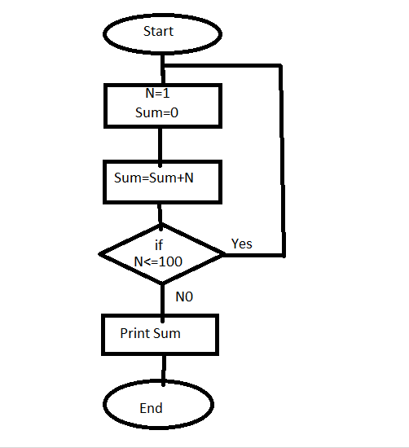

**Ans 3 write a pseudo code to perform the basic arithemetic operations.**

**Read num1 , num2**

**Sum=num1+num2**

**Sub=num1-num2**

**Mul=num1*num2**

**Div =num1/num2**

**Ans 4 Draw a FlowChart to Find the factorial of given positive integer N.**

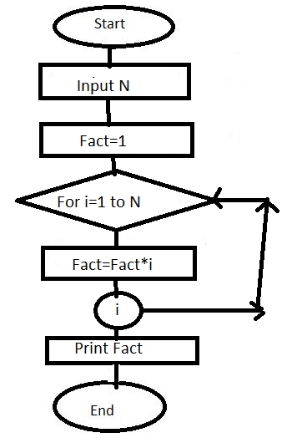

**Ans 5 Develop a flowchart to illustrate how to make a Land Phone Telephone Call.**

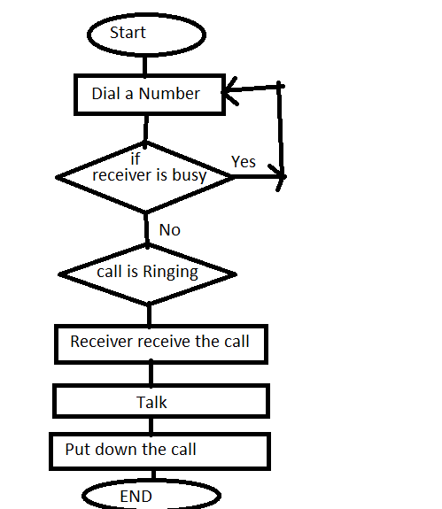

**Ans 6 Write an Algorithm to calculate the simple interest using the Formula.**

**Step-1 : Read the input PA,R,T**

**Step 2: Calculate SI=(PA*R*T)/100**

**Step 3: Print SI**

**Step 4:End**

**Ans 7 Write an algorithm to find the largest of Three numbers X,Y,Z**

**Step 1: Read the input X,Y,Z**

**Step 2 : if X>Y:**

**Large =X**

**Else:**

**Large =Y**

**Step 3 : if (Large<Z):**

**Step 4 : Large =Z**

**Step 5: print Large**

**Step 6 : Stop**

**Ans 8 : Write a algorithm which will Test whether a given integer value is prime or not?**

**Step 1: Read the input A**

**Step 2: if A%2==0**

**Print(“A is Prime”)**

**Step 3: else**

**Print(“A is Not prime”)**

**Step 4: end**

**Ans 9 : Draw a flowchart to find out the biggest of the three unequal positive Numbers.**

